Software Engineering Assignment
MODULE: 5 (Database)
SQL Queries
- Create table name: Student and Exam
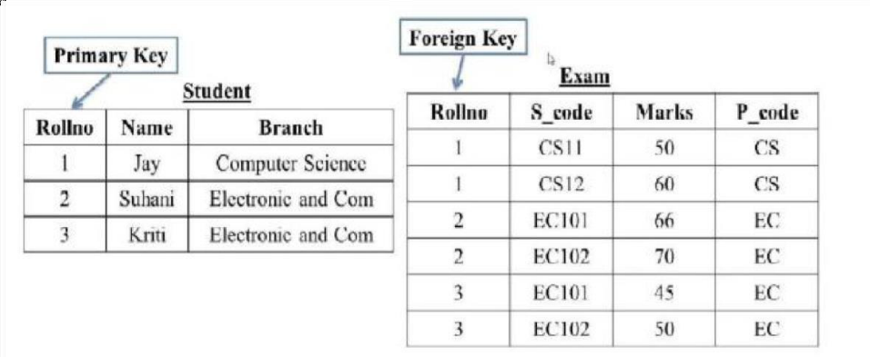

- Query to create table Student and enter data into it:
CREATE TABLE Student
(
Rollno int PRIMARY KEY,
Name varchar(30) ,
Branch varchar(50)
);
INSERT INTO Student (Rollno, Name, Branch)
VALUES
(1, 'Jay', 'Computer Science'),
(2, 'Suhani', 'Electronic and Com'),
(3, 'Kriti', ‘Electronic and Com');

- Query to create table Exam and enter data into it:
CREATE TABLE Exam
(
Rollno int,
S_code varchar(30) ,
Marks int,
P_code varchar(30)
);
Query to add Foreign Key: ALTER TABLE `Exam` ADD FOREIGN KEY (`Rollno`) REFERENCES `Student` (`Rollno`);

INSERT INTO Exam (Rollno, S_code, Marks,P_code)
VALUES
( 1,'CS11', '50', 'CS'),
( 1,'CS12', '60', 'CS'),
( 2,'EC101', '66', 'EC'),
( 2,'EC102', '70', 'EC'),
(3, 'EC101', '45', 'EC'),
( 3,'EC102', '50', 'EC');
- Create table name: Employee and Incentive
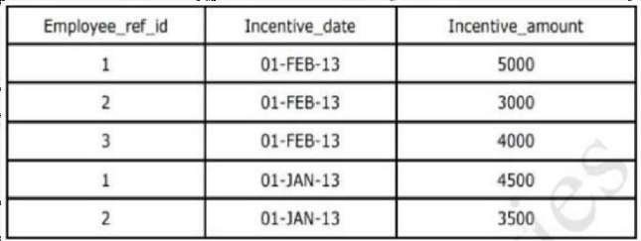
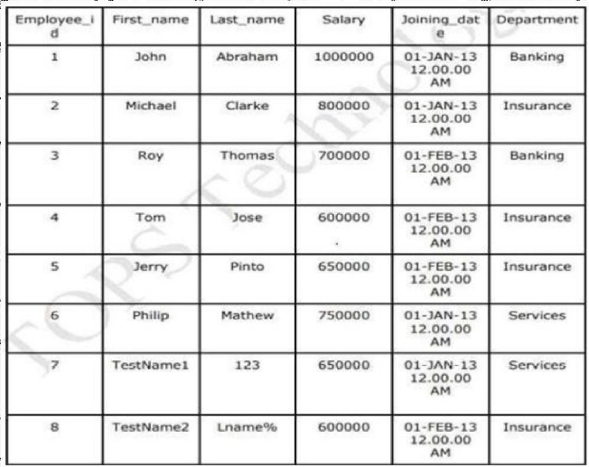
Employee Incentive

- Query to create table Employee and enter data into it:
CREATE TABLE Employee
(
Employee_id int AUTO_INCREMENT PRIMARY KEY,
First_name char(30) ,
Last_name char(50),
Salary int,
Joining_date varchar(30),
Department varchar(20)
);

INSERT INTO Employee (Employee_id, First_name, Last_name, Salary, Joining_date, Department)
VALUES
('John', 'Abraham', '1000000', '01-JAN-13 12.00.00 AM','Banking'),
('Micheal', 'Clarke', '800000', '01-JAN-13 12.00.00 AM','Insurance'),
('Roy', 'Thomas', '700000', '01-FEB-13 12.00.00 AM','Banking'),
('Tom', 'Jose', '600000', '01-FEB-13 12.00.00 AM','Insurance'),
('Jerry', 'Pinto', '650000', '01-JAN-13 12.00.00 AM','Insurance'),
('Philip', 'Mathew', '750000', '01-JAN-13 12.00.00 AM','Services'),
('Testname1', '123', '650000', '01-JAN-13 12.00.00 AM','Services'),
('Testname2', 'Lname%', '600000', '01-FEB-13 12.00.00 AM','Insurance');

- Query to create table Incentive and enter data into it:
CREATE TABLE Incentive
(
Employee_ref_id int,
Incentive_date varchar(30) ,
Incentive_amount int
);
Query to add Foreign Key: ALTER TABLE `Incentive` ADD FOREIGN KEY (`Employee_ref_id`) REFERENCES `Employee` (`Employee_id`);

INSERT INTO Incentive (Employee_ref_id, Incentive_date, Incentive_amount)
VALUES
( 1,'01-FEB-13', 5000),
( 2,'01-FEB-13', 3000),
( 3,'01-FEB-13', 4000),
( 1,'01-JAN-13', 4500),
( 2,'01-JAN-13', 3500);

- Query to get First_Name from employee table using Tom name “Employee Name”:
SELECT First_name
FROM Employee
WHERE First_name = 'Tom';

- Query to get FIRST_NAME, Joining Date, and Salary from employee table:
SELECT `First_name`, `Joining_date`, `Salary`
FROM`Employee`;

- Get all employee details from the employee table order by First_Name Ascending and Salary Descending:
SELECT *
FROM `Employee`
ORDER BY `First_name`ASC, `Salary`DESC;

- Get employee details from employee table whose first name contains ‘J’:
SELECT *
FROM `Employee`
WHERE `First_name`
LIKE 'J%';

- Get department wise maximum salary from employee table order by salary ascending:
SELECT Department, MAX(Salary) AS MaxSalary
FROM employee
GROUP BY Department
ORDER BY MaxSalary ASC;

- Select first_name, incentive amount from employee and incentives table for those employees who have incentives and incentive amount greater than 3000:
SELECT Employee.First_name, Incentive.Incentive_amount
FROM Employee
JOIN Incentive ON Employee.Employee_id = Incentive.Employee_ref_id
WHERE Incentive.Incentive_amount > 3000;

- Create After Insert trigger on Employee table which insert records in viewtable:
-- Create ViewTable
CREATE TABLE ViewTable
(
Employee_id int PRIMARY KEY,
First_name char(30),
Last_name char(50),
Salary int,
Joining_date varchar(30),
Department varchar(20)
);

-- Create AFTER INSERT trigger
DELIMITER $$
CREATE TRIGGER `insert_data` AFTER INSERT ON `viewtable`
FOR EACH ROW BEGIN
INSERT INTO employee (Employee_id, First_name, Last_name, Salary, Joining_date, Department)
VALUES (NEW.Employee_id, NEW.First_name, NEW.Last_name, NEW.Salary, NEW.Joining_date, NEW.Department);
END $$

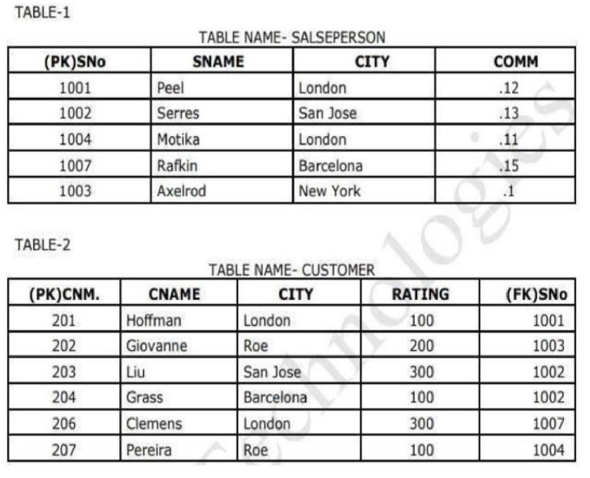
- Create table name: Salesperson and Customer

- Query to create table Salesperson and enter data into it:
CREATE TABLE Salesperson
(
SNo int PRIMARY KEY,
SNAME char(30) ,
CITY char(50),
COMM decimal (5,2)
);

INSERT INTO Salesperson (SNo, SNAME, CITY, COMM)
VALUES
(1001, 'Peel', 'London', '0.12'),
(1002, 'Serres', 'San Jose', '0.13'),
(1004, 'Motika', 'London', '0.11'),
(1007, 'Rafkin', 'Barcelona', '0.15'),
(1003, 'Axelrod', 'New York', '0.1');
- Query to create table Customer and enter data into it:
CREATE TABLE Customer
(
CNM int PRIMARY KEY,
CNAME char(30) ,
CITY char(50),
RATING int,
SNo int,
FOREIGN KEY (SNo) REFERENCES Salesperson(SNo)
);

INSERT INTO Customer (CNM, CNAME, CITY, RATING, SNo)
VALUES
(201, 'Hoffman', 'London', '100', '1001'),
(202, 'Giovanne', 'Roe', '200', '1003'),
(203, 'Liu', 'San Jose', '300', '1002'),
(204, 'Grass', 'Barcelona', '100', '1002'),
(206, 'Clemens', 'London', '300', '1007'),
(207, 'Pereira', 'Roe', '100', '1004');

- Query to get all orders for more than $1000- Original question
Query to get all orders for more than 100 ratings – New question
SELECT *
FROM Customer
WHERE Rating>100;
- Query to get names and cities of all salespeople in London with commission above 0.12:
SELECT SNAME, CITY, COMM
FROM Salesperson
WHERE CITY = 'London' AND COMM > 0.12;

- Query to get all salespeople either in Barcelona or in London:
SELECT *
FROM Salesperson
WHERE CITY IN ('Barcelona', 'London');

- Query to get all salespeople with commission between 0.10 and 0.12. (Boundary values should be excluded).
SELECT *
FROM Salesperson
WHERE COMM > 0.10 AND COMM < 0.12;

- Query to get all customers excluding those with rating <= 100 unless they are located in Rome
SELECT *
FROM Customer
WHERE (RATING > 100 OR CITY = 'Rome');

- Write a SQL statement that displays all the information about all salespeople.

salesman_id | name | city | commission
------------+------------+-----------+------------
5001 | James Hoog | New York | 0.15
5002 | Nail Knite | Paris | 0.13
5005 | Pit Alex | London | 0.11
5006 | Mc Lyon | Paris | 0.14
5007 | Paul Adam | Rome | 0.13
5003 | Lauson Hen | San Jose | 0.12

- Query to create table Salesman and enter data into it:
CREATE TABLE Salesman
(
Salesman_id int PRIMARY KEY,
name char(30) ,
city char(50),
commision decimal (5,2)
);

INSERT INTO Salesman (salesman_id, name, city, commision)
VALUES
(5001, 'James Hoog', 'New York', '0.15'),
(5002, 'Nail Knite', 'Paris', '0.13'),
(5005, 'Pit Alex', 'London', '0.11'),
(5006, 'Mc Lyon', 'Paris', '0.14'),
(5007, 'Paul Adam', 'Rome', '0.13'),
(5003, 'Lauson Hen', 'San Jose', '0.12');

- Query to display all information of all salespeople:
SELECT *
FROM Salesman;

- From the following table, write a SQL query to find orders that are delivered by a salesperson with ID. 5001. Return ord_no, ord_date, purch_amt.

Sample table: orders

ord_no purch_amt ord_date customer_id salesman_id
--------- ---------- ---------- ----------- -----------
70001 150.5 2012-10-05 3005 5002
70009 270.65 2012-09-10 3001 5005
70002 65.26 2012-10-05 3002 5001
70004 110.5 2012-08-17 3009 5003
70007 948.5 2012-09-10 3005 5002
70005 2400.6 2012-07-27 3007 5001
70008 5760 2012-09-10 3002 5001
70010 1983.43 2012-10-10 3004 5006
70003 2480.4 2012-10-10 3009 5003
70012 250.45 2012-06-27 3008 5002
70011 75.29 2012-08-17 3003 5007
70013 3045.6 2012-04-25 3002 5001

- Query to create table orders and enter data into it:
CREATE TABLE Orders
(
ord_no int(20) ,
purch_amt decimal(5,2) ,
ord_date DATE(10),
customer_id int(20),
salesman_id int (20),
FOREIGN KEY (salesman_id) REFERENCES salesman(salesman_id)
);

INSERT INTO Orders (ord_no, purch_amt, ord_date, customer_id, salesman_id)
VALUES
(70001, '150.5', '2012-10-05', '3005', '5002'),
(70009, '270.65', '2012-09-10', '3001', '5005'),
(70002, '65.26', '2012-10-05', '3002', '5001'),
(70004, '110.5', '2012-08-17', '3009', '5003'),
(70007, '948.5', '2012-09-10', '3005', '5002'),
(70005, '2400.6', '2012-07-27', '3007', '5001'),
(70008, '5760', '2012-09-10', '3002', '5001'),
(70010, '1983.43', '2012-10-10', '3004', '5006'),
(70003, '2480.4', '2012-10-10', '3009', '5003'),
(70012, '250.45', '2012-06-27', '3008', '5002'),
(70011, '75.29', '2012-08-17', '3003', '5007'),
(70013, '3045.6', '2012-04-25', '3002', '5001');

- Query to find ord_no, ord_date, purch_amt that are delivered by salesperson with ID. 5001:
SELECT ord_no, ord_date, purch_amt
FROM Orders
WHERE salesman_id = 5001;

- From the following table, write a SQL query to calculate the average price for a manufacturer code of 16. Return avg.
Sample table: item_mast

PRO_ID PRO_NAME PRO_PRICE PRO_COM

101 Mother Board 3200.00 15
102 Key Board 450.00 16
103 ZIP drive 250.00 14
104 Speaker 550.00 16
105 Monitor 5000.00 11
106 DVD drive 900.00 12
107 CD drive 800.00 12
108 Printer 2600.00 13
109 Refill cartridge 350.00 13
110 Mouse 250.00 12

- Query to create table Item_mast and enter data into it:
CREATE TABLE Item_mast
(
PRO_ID int (20) AUTO_INCREMENT PRIMARY KEY,
PRO_NAME char(30) ,
PRO_PRICE decimal(8,2),
PRO_COM int (20)
);

INSERT INTO Item_mast (PRO_ID, PRO_NAME, PRO_PRICE, PRO_COM)
VALUES
(101, 'Mother Board', '3200.00', '15'),
(102, 'Key Board', '450.00', '16'),
(103, 'ZIP drive', '250.00', '14'),
(104, 'Speaker', '550.00', '16'),
(105, 'Monitor', '5000.00', '11'),
(106, 'DVD drive', '900.00', '12'),
(107, 'CD drive', '800.00', '12'),
(108, 'Printer', '2600.00', '13'),
(109, 'Refill cartridge', '350.00', '13'),
(110, 'Mouse', '250.00', '12');

- Query to select a range of products whose price is in the range Rs.200 to Rs.600. Begin and end values are included. Return pro_id, pro_name, pro_price, and pro_com.
SELECT *
FROM Item_mast
WHERE PRO_PRICE <= 600 AND PRO_PRICE >= 200;

- Query to calculate the average price for manufacturer code of 16 and return average:
SELECT AVG(PRO_PRICE) AS AveragePrice
FROM Item_mast
WHERE PRO_COM = 16;

- Query to display the pro_name as 'Item Name' and pro_price as 'Price in Rs.':
SELECT
PRO_NAME AS 'Item Name',
PRO_PRICE AS 'Price in Rs.'
FROM Item_mast;

- Query to find the items whose prices are higher than or equal to $250. Order the result by product price in descending, then product name in ascending. Return pro_name and pro_price:
SELECT
PRO_NAME,
PRO_PRICE
FROM Item_mast
WHERE PRO_PRICE >= 250
ORDER BY PRO_PRICE DESC, PRO_NAME ASC;

- Query to calculate average price of the items for each company. Return average price and company code:
SELECT
PRO_COM AS 'Company Code',
AVG(PRO_PRICE) AS 'Average Price'
FROM Item_mast
GROUP BY PRO_COM;

